 | Teacher considerations | What this could look like in the classroom

Planning | - What does success look like? Write your model or exemplar  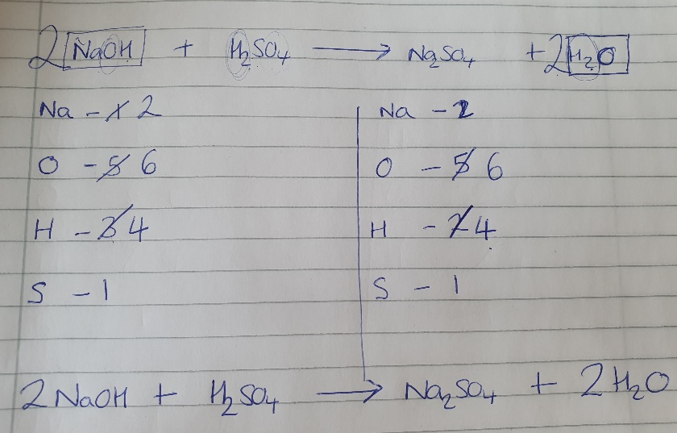  - Break down into the knowledge and skills/write your know and show chart:  TKT the identity of a substance cannot be changed when balancing (i.e cannot change the ‘little’ number)  TKT same elements must be present in the reactants and products  TKT the same number of atoms must be present in the reactants and products  TBAT list the 7 steps to balancing an equation  - What is the purpose of my think aloud? To model the steps taken to balance a chemical symbol equation  - What thinking process do you want the children to go through? Write this down.  Steps to success:  - Copy out equation, leaving gaps  - Write out elements for reactants and products and draw table  - Count  - Look for ‘problems’ and circle  - Balance with big numbers (one problem at a time)  - Repeat counting, circling and balancing until there are no ‘problems’  - Do a final count to check that you have the same number of atoms on each side of the equation  Are the children familiar with any of these steps already?  They will be familiar with identifying the elements in a chemical formula from my previous I do. Will reiterate to remind pupils.  Where are children likely to go wrong?  The most common error is that pupils think they can change the ‘little’ number- to avoid this I will draw a box around each molecule when I balance to show it is a WHOLE- and reiterate we cant change the ‘identity’ of the substance.  Some pupils may directly try to balance without counting/laying out the elements.
Set up | Now that we have practiced unpicking a chemical formula and we are confident on what each formula tells us, we are ready to learn how to balance a chemical equation.  When we look at a chemical SYMBOL equation, it tells us HOW MANY units there are of each substance- and this is really important information for us as scientists when it comes to knowing the quantities and ratios of substances to react together.  There are lots of steps to balancing equations but you are going to watch me balance a few equations first so that you can follow the same steps yourself!  As you watch me, you need to watch the steps I take and what tools I use to help me when I get stuck.
Think aloud | So here is my equation:  NaOH + H2SO4 Na2SO4 + H2O  We call this a chemical symbol equation. You may have been used to seeing this in words, but when we balance, we use symbols.  My first step is to:  - Write the equation out, leaving gaps for me to add numbers later.  Notice that when I have written it out, all my reactants are on the LEFT hand side, and my products are on the RIGHT hand side of the arrow.  My second steps is to:  - Draw a line down the middle to separate the LHS and RHS and then LIST the elements out  I know from earlier that when I look at a chemical formula, every element has only one capital letter. PAUSE So, I’m going to start here (NaOH)… I can see Na- I am going to write this down. The next element I see is O, Oxygen, so I am going to write O here… (repeat for each element in reactants and products)  I am going to repeat this for the right hand side, and to make it easier for me in the next step, I am going to list the elements on the RIGHT hand side in the SAME order as the left hand side.  My third step is:  - Count the number of atoms on each side.  I’ve listed Na first, so lets check every molecule on the LEFT HAND side of the arrow (reactants)… I can see 1…. I’m going to write 1 next to Na PAUSE  Next is O, so I can see 1 Oxygen in NaOH…. Lets check H2SO4… ah! I can O and I can see a little 4 next to the O). That tells me there are 4 Oxygens in this molecule PLUS the 1 from NaOH, so 4 +1… that gives me FIVE Oxygens- so I’m going to write 5 next to O.  Repeat for all molecules…  Let’s just remind ourselves of the steps we have taken so far:  - I’ve written out my equation leaving enough space before each molecules  - I’ve listed the elements in order on both the left and right hand side of my equations (in the SAME order!)  - And I’ve counted the number of atoms of each side  Now, let’s move onto the FOURTH step:  - Circle ‘any problems’.  Hmmm… what do I mean by problems? Well, I can see that I have the same number of oxygens on the LHS and RHS, and the same number of Sulphur atoms on the LHS and RHS – so they are balanced. BUT, I can see that Na and H have different number of atoms on the LHS and RHS so they are a ‘problem’- so I am going to circle them in my equation so I can FOCUS on those atoms first. PAUSE  Right, so now I have circled my problems, I need to address them!  - I need to balance the ‘problems’ by placing a BIG number in front of the WHOLE molecule.  REMEMBER, I CANNOT change the little number as this means I would be changing the identity (like the personality) of the molecule, I just want to change the NUMBER/AMOUNT of the molecule.  Let’s start with Hydrogen- I have 3 on the LHS but only 2 on the RHS, so I need to INCREASE on the RHS. Let’s look at H2O- water on the RHS. I can’t change what is inside the molecule (Draws box around it), but I can change HOW MANY water molecules units I have- I’m going to put a 2 in front of it. That means I have 2 of everything in this molecule. 2 X H2= Two multiply by two Hydrogens = 4  I have also doubled my O, and remember just because there isn’t a little number next to the O, doesn’t mean there isn’t one- scientists are lazy remember! There is 1, but I have put a BIG TWO in front, so 1X2 = 2. I also need to remember that on the RHS, there is Na2SO4, there are 4 Os there, so 2 plus 4 = 6  Cross out and change O to 6  Now, I have 6 oxygen and 4 hydrogen on the RHS. Ahhhh but this is STILL not balanced, as I can see on my LHS that I have 5 O and 3 H.  My 6th step is:  - Repeat balancing where there are ‘problems’  So I now need to increase the amount on this side. I can ALSO see that my Na is unbalanced. I’m going to see if there is a molecule which has Na, O AND H to see if I can tackle this problem together. *searches*….. ah yes NaOH! Great, let me try putting a 2 in front of this WHOLE molecule (draws box around).  Now, let me recount – 2 Na, 6O, 4 H  My final step is to:  - Do a final count to check that you have the same number of atoms on each side of the equation  *does final count* - checks all balanced.  Review steps with pupils:  - Copy out equation, leaving gaps  - Write out elements for reactants and products and draw table  - Count  - Look for ‘problems’ and circle  - Balance with big numbers (one problem at a time)  - Repeat counting, circling and balancing until there are no ‘problems’  - Do a final count to check that you have the same number of atoms on each side of the equation

